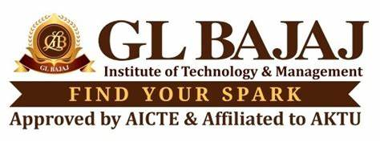

Centre for Career Development

15/01/2025

**NOTICE**

**Subject:** Assignments for B. Tech. 2026 Passing Out Batch

All students of the B. Tech. 2026 Passing Out Batch are expected to execute under mentions assignments before start of their training sessions on **11/02/2024**. Their **academic classes will run as per the date and Timetable shared by respective departments**. The assignments must be executed between **January 25, 2025, and February 10, 2025**.

**Details of the Assignments:**

1. **Exercises (Daily basis):**

Each student is required to solve:

* + - **Three (3)** problems related to **Data Structures and Algorithms (DSA)** on any coding platform of their choice (e.g. Leetcode, Hackerranck, Codeforces etc)
    - **One (1)** problem related to **Object-Oriented Programming (OOPS)** on any coding platform of their choice.
    - **One (1)** problem related to **DBMS** on any coding platform of their choice

1. **Selection of Project:** (Progress to be updated on weekly basis) The Project should be selected from following sources only:
   * + **Smart India Hackathon (SIH)** website.
     + **Websites of top 30 recruiters** as per the list already shared with students.
2. **Online Submission Guidelines:**
   * Solutions of OOPS problem statement must be uploaded to the student’s **GitHub profile on daily basis** as a dedicated repository.
   * The repository must be named in the format: **Assignment_BTech2026_[Roll Number]**.
   * Include a README file in the repository with the following details:
     + Problem statements.
     + Coding platform used.
     + Approach and solution explanation.

**Important Instructions:**

* A Google sheet will be shared for updates on daily basis, and it will be compulsory to all students.
* Ensure originality in your work. Plagiarism will result in strict penalties.
* Maintain proper documentation and citation formats as per departmental guidelines.
* The training and placement score will be given a weightage of 25% for activities during this period.

Dr. V. R Mishra

Dean,

Centre for Career Development